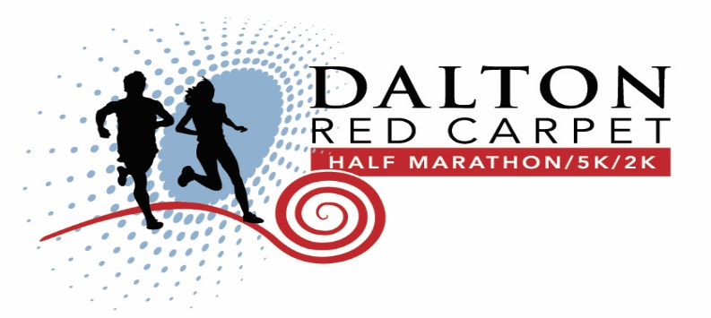
Friends of City of Refuge
Sponsorship Level
Dalton Red Carpet Half Marathon
10K, 5K and Fun Run

The Dalton Red Carpet Half Marathon has become one of the South’s premier running events and has made its mark as one of the most hospitable and enjoyable half marathons in Georgia. As a Sponsor of the race, your dollars will help benefit City of Refuge providing a platform for to raise awareness and funds, as well as educate others about the plight of the poor and homeless in Northwest Georgia.

This race is more than a community event. The revenue raised with this year's funds will allow City of Refuge to expand their youth and educational center for at risk kids in the community. City of Refuge is committed to addressing the literacy needs of low-income, under-achieving households within our area. This program addresses both poverty obstacles and educational needs of our students.

This year, the eighth annual Dalton Red Carpet Half Marathon, 5K and 2K will be held on October 20, 2018 in historic downtown Dalton, Georgia. This event will be produced in conjunction with the Dalton Convention and Visitors Bureau and the Carpet Capital Running Club.

Over 1,000 runners will take to the streets competing and completing their individual goals set earlier in the year. Half Marathon participants will receive a high-quality wind shirt and finisher medal. 5K and 2K fun run/walk participants will receive a t-shirt. Awards will be presented to the top three finishers in each category for the Half Marathon, 5K. The course will include aid stations, motivation stations, finish line refreshments and music.

Schedule: Friday October 19, 2018
Participant packet pick-up at the Bradley Wellness Center
Saturday October 20, 2018
- Races begin at the intersection of King and Selvedge St. Downtown Dalton, GA

Friends of City of Refuge Sponsorship Commitment

Friends Level Sponsor: ____________ ______ ___________
(Company Name)

Your sponsorship will:

- Build teamwork and camaraderie among employees outside the workplace by forming a corporate team.
- Experience the excitement of race day and the satisfaction of knowing that your company is contributing to a worthy cause that directly benefits the local community.
- Opportunity to distribute company material and products in race packets (items need to be received by October 5, 2018).
- Free booth opportunity at Start/ Finish Line

Your corporate name will be prominently displayed on the following:

- Banner listing “Our Friends” on Awards Stage
- Race Website (daltonhalf.com)

Sponsorship commitment: $ 250

Sponsorship commitment: $ 250 (Should be received in our office no later than July 20, 2018. If you face a challenge meeting this requested deadline please contact Pamela Cudd at 706-226-1301)

Company Address_______________________________________________
_______________________________________________
Company Contact ______________________Email ____________________
(Please Print)
Contact Phone No. __________________2nd. Contact No._______________
Agreed: ____________________________ Date: ____________________
Signature

Checks made payable to:
City of Refuge Dalton
2015 Sheffield Place, Dalton, GA 30720
ATT. Pamela Cudd
Office 706-226-1301 / Fax 706-226-5097

NOTE: Please forward company logo for advertisement
adpcudd@hotmail.com

